Taken by a Canadian Combat photographer inside of KAF
“One of my mates sent me this. Taken by a Canadian Combat photographer inside of KAF, perfect timing and a great shot. This is something you and I have seen a few times before, but I never sat around waiting for it to hit, didn't like sand between the cheeks of arse”. Dave B

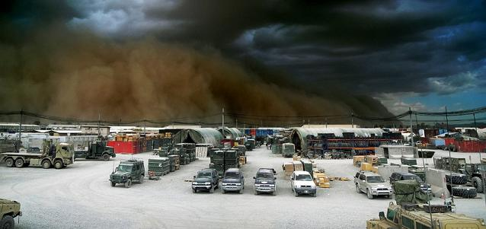
Thanx Rod & Dave B

