"Bill thought that he was president too."
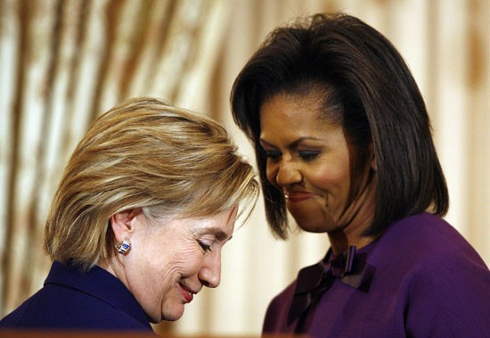
Gotcha Bitch
Thanx Paul

